Sunday, 2 June 2024
Arise & Build Series – Part 4 Caring For New Believers

To arise and build spiritually, it is essential that we care for new believers. Just like in the natural, when a child is born that cannot feed themselves. A newborn baby cannot survive if not cared for by the parents.
Truth to take hold of: You have what a new believer needs to draw close to Jesus and grow spiritually.

- What do newborn Christians need?
  - They need someone to feed them – 1 Peter 2:2
  - The need prayer – Galatians 4:19 (The prayers in Ephesians chapters 1 and 3)
  - They need community – Acts 2:42
  - They need a godly example – 1 Corinthians 11:1, John 17:19
- Why is it important to follow up on new believers immediately?
  - The first few days of the new believer’s life are the most critical.
  - The enemy will attack the new believer to try to get them to reject their new faith.
  - The new believer must be visited, encouraged, and taught about their new life in Christ.
  - Visit the new believer at work, at a coffee shop, at their home, or invite them to your home for follow-up.
  - Bring them to your Care Group, church, and the First Steps With Jesus Class.
- You have what a new believer needs to continue in Jesus and grow spiritually – John 7:38-39.

A simple plan to Arise and Build spiritually.
1 win 1
นำ 1 คนต่อปี | 1 | 2 | 3 | 4 | 5 | 6 | 7 | 8 | 9 | 10
50 คน | 100 | 200 | 400 | 800 | 1,600 | 3,200 | 6,400 | 12,800 | 25,600 | 51,200
100 คน | 200 | 400 | 800 | 1,600 | 3,200 | 6,400 | 12,800 | 25,600 | 51,200 | 102,400

Assimilation Ministry Plan
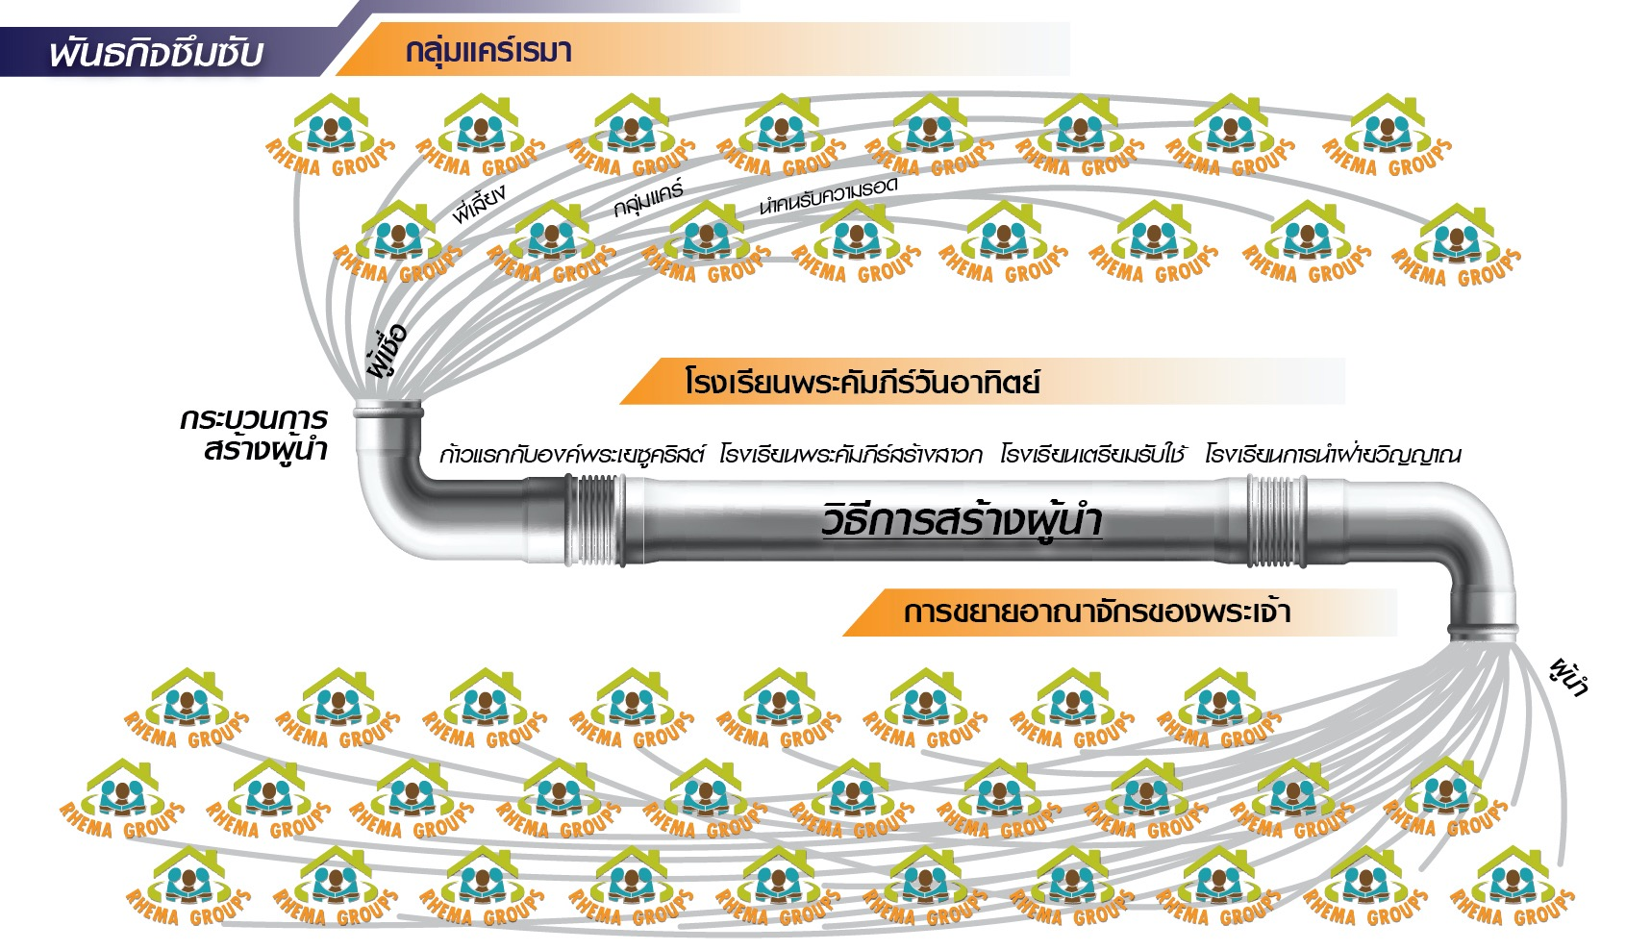

Conclusion: Inside you is the knowledge and a river of living water that new believers need to continue and grow in their relationship with Jesus. The knowledge and the living waters in you enable you to care for new believers effectively. Will you allow God to use you to care for new believers?

Discussion Questions:
- What are the four basic needs of every new believer?
- Why is it important to follow up on new believers immediately?
- Who will you believe God for that you will lead to Jesus and follow up on this year?

